Pseudocode

# Q1. Write a Pseudocode to check if a number provided by the user is positive, negative, or zero.

1. START
2. INPUT num
3. IF NUM > 0 THEN
4. PRINT “Number is positive”
5. ELSEIF NUM < 0 THEN
6. PRINT “Number is negative”
7. ELSE
8. PRINT “Number is zero”
9. ENDIF
10. END

# Q2. Write Pseudocode to Find the Largest of Three Numbers

1. START
2. INPUT numA, numB, numC
3. IF numA > numB AND numA > numC THEN
4. PRINT “Number 1 is the largest”
5. ELSEIF numB > numC THEN
6. PRINT “Number 2 is the largest”
7. ELSE
8. PRINT “Number 3 is the largest”
9. ENDIF
10. END

Algorithms

# Q1. Write an algorithm that can calculate the Circumference of a Circle.

1. Ask the user to enter the **radius**.
2. Set **Circumference** to 2*3.142\***radius**
3. Display **Circumference** to the user

# Q2. Write an algorithm that can calculate the Perimeter of a Triangle.

1. Ask the user to enter **LenA, LenB, LenC**
2. Set **Perimeter** to **LenA + LenB + LenC**
3. Display **Perimeter** to the user.

GitHub

# Q1. Create a GitHub Repository

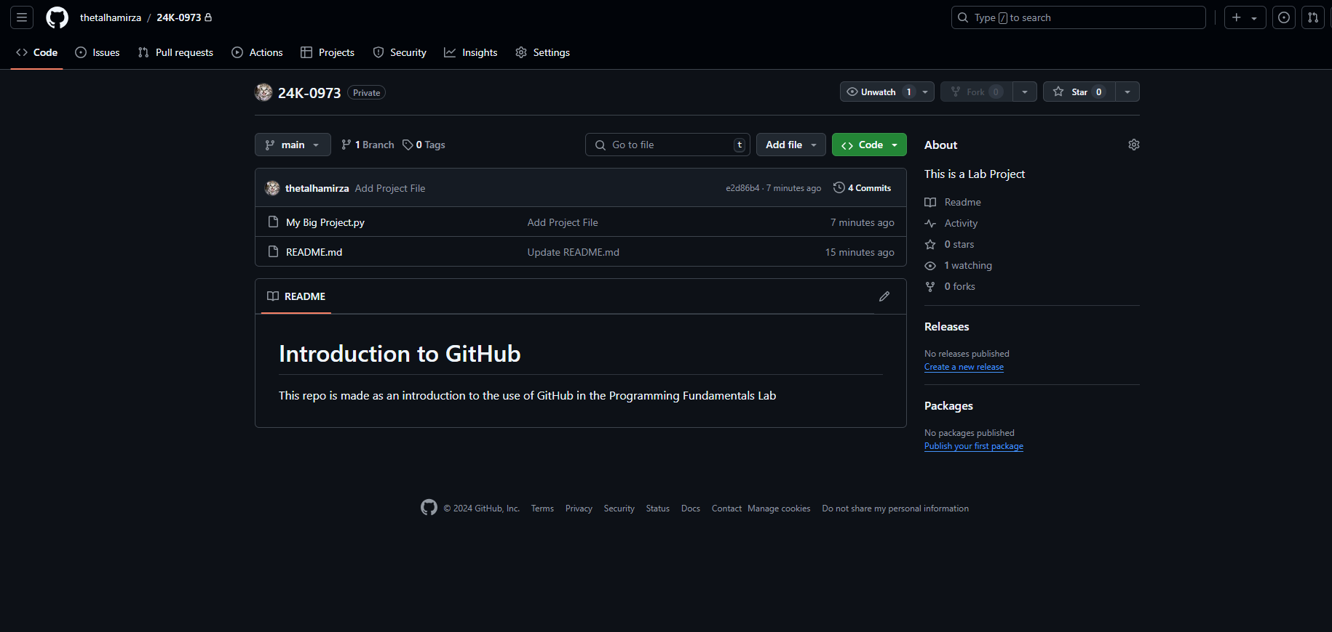

Q2. Create a README.md file in your GitHub repository with two sections, each having its own heading.

